Services :

Mouth Hygiene with Microscope:

**You may ask why we go through the effort of using a microscope for routine dental cleanings. Is this truly necessary?**

- It is. Here is why…

Our dental hygienists use a microscope and intra-oral camera when assessing your teeth and during cleanings. You can choose to watch a live video of us cleaning your teeth. This will allow you to see where we find plaque and tartar in your mouth. If you prefer to relax during your visit, you can ask to watch a movie or listen to music of your choice instead.

**“Why would I want to watch my teeth being cleaned?”**

* you will see how well you brush your teeth and which areas need more attention
* visualizing and knowing where plaque or tartar accumulates will allow you to improve how you brush your teeth at home and allow for better oral care at home
* you will obtain a better understanding for the use of dental floss and interdental brushes
* we will point out infected areas and create your personalized “brush plan” to help resolve infections in less than 14 days.

**“How we guarantee a detailed and improved dental cleaning experience”**

LIGHT AND MAGNIFICATION - The use of a microscope allows us to not only better visualize your teeth with improved and powerful lighting, but also magnify what we see by a factor of 20. This allows us to detect plaque and tartar that could otherwise be missed. It also guarantees a precise removal of plaque and tartar without removing any healthy dental tissue.

For more information u can visit our website : [www.mundhygiene-zahnarzt.at](http://www.mundhygiene-zahnarzt.at)

**Bleaching:**

**Teeth** **whitening**

###### Teeth whitening is a an excellent way to restore the natural color of your teeth and remove stains that have accumulated over time. To do this, we utilize the Philipps ZOOM procedure (in-office tooth whitening) and/or a tray whitening system (at-home tooth whitening). We recommend a combination of both to accomplish the best results. We advise that you treat any dental disease prior to whitening your teeth in order to avoid unwanted reactions.

In-office whitening

###### When we whiten your teeth in the office, a whitening gel is applied onto your teeth. Then, we use the Philipps ZOOM lamp to shine a light onto your teeth for about 15 minutes. Depending on how much lighter you wish your teeth to be, and to obtain the best results, this process is repeated 3 to 4 times.

At-home whitening

###### First, we make an impression of your teeth so we can create your personalized whitening trays.  At home, you will apply a whitening gel into the trays and wear them daily for few hours a day. Treatment should total a week.

###### It is difficult to predict how much lighter your teeth will become as the results can vary with each person. In general, you can expect a very obvious change in the color of your teeth after 2-3 sessions, which will last for about 2-3 years depending on each patient’s life style (smoker, non smoker, coffee drinker etc).

###### Please contact us today to see if you are a candidate for this type of teeth whitening.

For (Hussien)

The other pic to make like foto album above with movement like this

###### [Bildergebnis für philips zoom](https://www.google.at/url?sa=i&rct=j&q=&esrc=s&source=images&cd=&cad=rja&uact=8&ved=0ahUKEwjGqLHZ6ePWAhVREVAKHaPGBggQjRwIBw&url=https://www.philips.de/c-p/DIS578_01/zoom-whitespeed-einfache-zahnaufhellung-bei-ihrem-arzt&psig=AOvVaw2ccLLcJDcmZtruGT9afqjZ&ust=1507648291975457)[Bildergebnis für philips zoom](http://www.google.at/url?sa=i&rct=j&q=&esrc=s&source=images&cd=&cad=rja&uact=8&ved=0ahUKEwj7s5fw6ePWAhVLKlAKHRxCBY8QjRwIBw&url=http://www.notdressedaslamb.com/2016/12/how-whiter-smile-can-take-years-off-your-looks-philips-zoom-teeth-whitening-review.html&psig=AOvVaw08ogEiCcVyCQkSo6f9SGkd&ust=1507648340855633)[Ähnliches Foto](https://www.google.at/url?sa=i&rct=j&q=&esrc=s&source=images&cd=&cad=rja&uact=8&ved=0ahUKEwiGj6ek6uPWAhUNZVAKHSBjDg4QjRwIBw&url=https://landmark.dental/dentist-kelowna-dental-aesthetics/teeth-whitening/&psig=AOvVaw08ogEiCcVyCQkSo6f9SGkd&ust=1507648340855633)[Ähnliches Foto](http://www.google.at/url?sa=i&rct=j&q=&esrc=s&source=images&cd=&cad=rja&uact=8&ved=0ahUKEwitpvm96uPWAhVKZ1AKHcO1CQkQjRwIBw&url=http://www.blumenroehr.de/Prophylaxe/bleaching/&psig=AOvVaw08ogEiCcVyCQkSo6f9SGkd&ust=1507648340855633)

[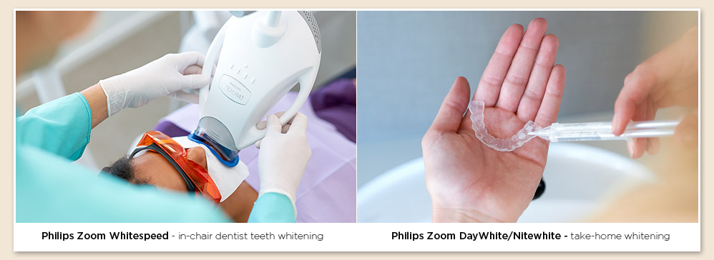](http://www.google.at/url?sa=i&rct=j&q=&esrc=s&source=images&cd=&ved=0ahUKEwiskP-I6uPWAhVFb1AKHaTLDNgQjRwIBw&url=http://leemingdental.com.au/cosmetic-dentistry/philips-zoom-teeth-whitening-speed-white/&psig=AOvVaw08ogEiCcVyCQkSo6f9SGkd&ust=1507648340855633)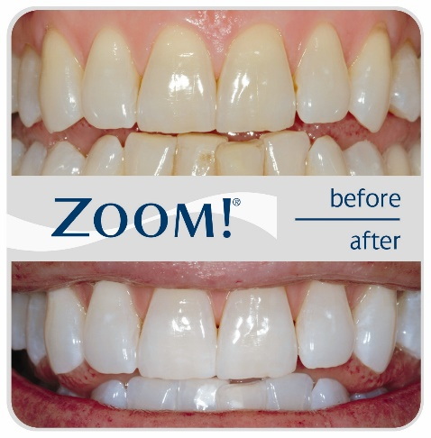

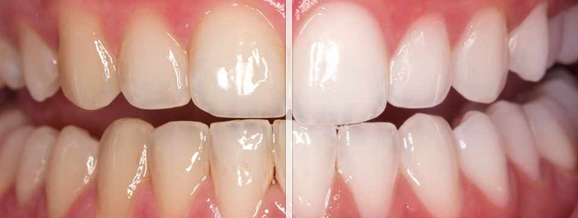

Dental implant

A **dental implan** : is a surgical component that interfaces with the bone of the jaw or skull to support a dental prosthesis such as a crown, bridge, denture, facial prosthesis or to act as an orthodontic anchor. The basis for modern dental implants is a biologic process called osseointegration, in which materials such as titanium form an intimate bond to bone. The implant is first placed so that it is likely to osseointegrate, then a dental prosthetic is added. A variable amount of healing time is required for osseointegration before either the dental prosthetic (a tooth, bridge or denture) is attached to the implant or an abutment is placed which will hold a dental prosthetic.

Single Tooth

There no better, long-lasting option to restoring a missing tooth than a dental implant fitted with a crown.

Traditional replacement of a single tooth using a dental implant is often completed over multiple visits

* Consultation and planning, including initial exam, imaging of your teeth, questions about your dental and medical history, and discussion of your treatment options.
* Placement of the dental implant, a substitute for the missing natural tooth root, either with or without a built-in abutment

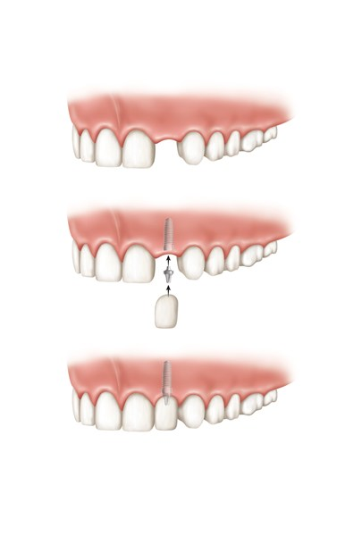

Multiple Teeth Dental Implants

Replacing multiple teeth using dental implants with individual crowns or with an implant-supported fixed bridge gives your teeth a level of fit, feel and functionality that is not possible with other treatment options. The process is often completed over multiple visits:

* Consultation and planning, including initial exam, imaging of your teeth, questions about your dental and medical history, and discussion of your treatment options.
* Placement of the dental implants that will be used to support your replacement teeth

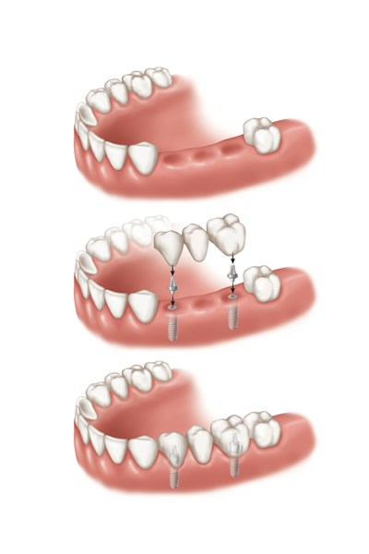

* We are working together since 10 years with Univ.-Prof. DDr. Werner Zechner our Implantat expert , for More Information u can visit his Webseite : [www.profzechner.at](http://www.profzechner.at)

For (Hussien)

The other pic to make like foto album above with movement like this

